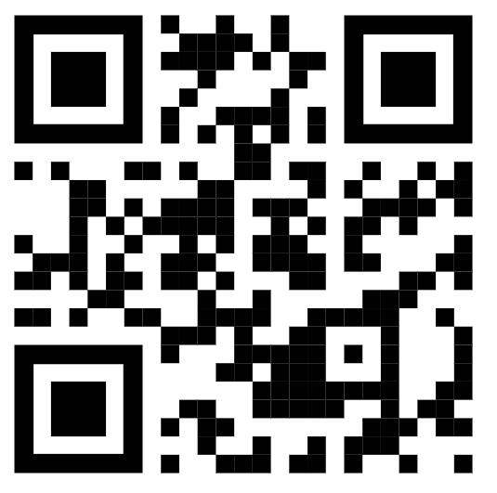
Thank you for ordering your
bGeigieZen from Safecast.

Prepared and packed by:
Name :Rob Oudendijk
Date :2024-10-12

